
Map for the Together Trust
Cheadle Campus
Address:

Together Trust
Schools Hill
Cheadle
Stockport
SK8 1JE

Telephone: 0161 283 4848 (switchboard)

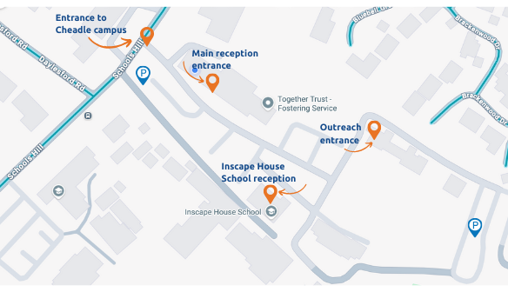

Access to the Campus

On arrival at the front gates please provide your name to the security guard and they will give you access onto the campus. Proceed to a suitable car space as you will find there is ample free parking, and several disability spaces are available.

Central Office

Please report to reception which is the first building on your left as you arrive on campus and press the bell to gain access to the building.

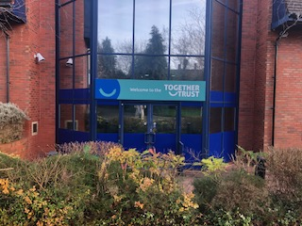

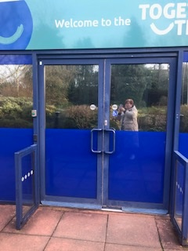
Press this door bell

Inscape House School

Please report to the reception.

