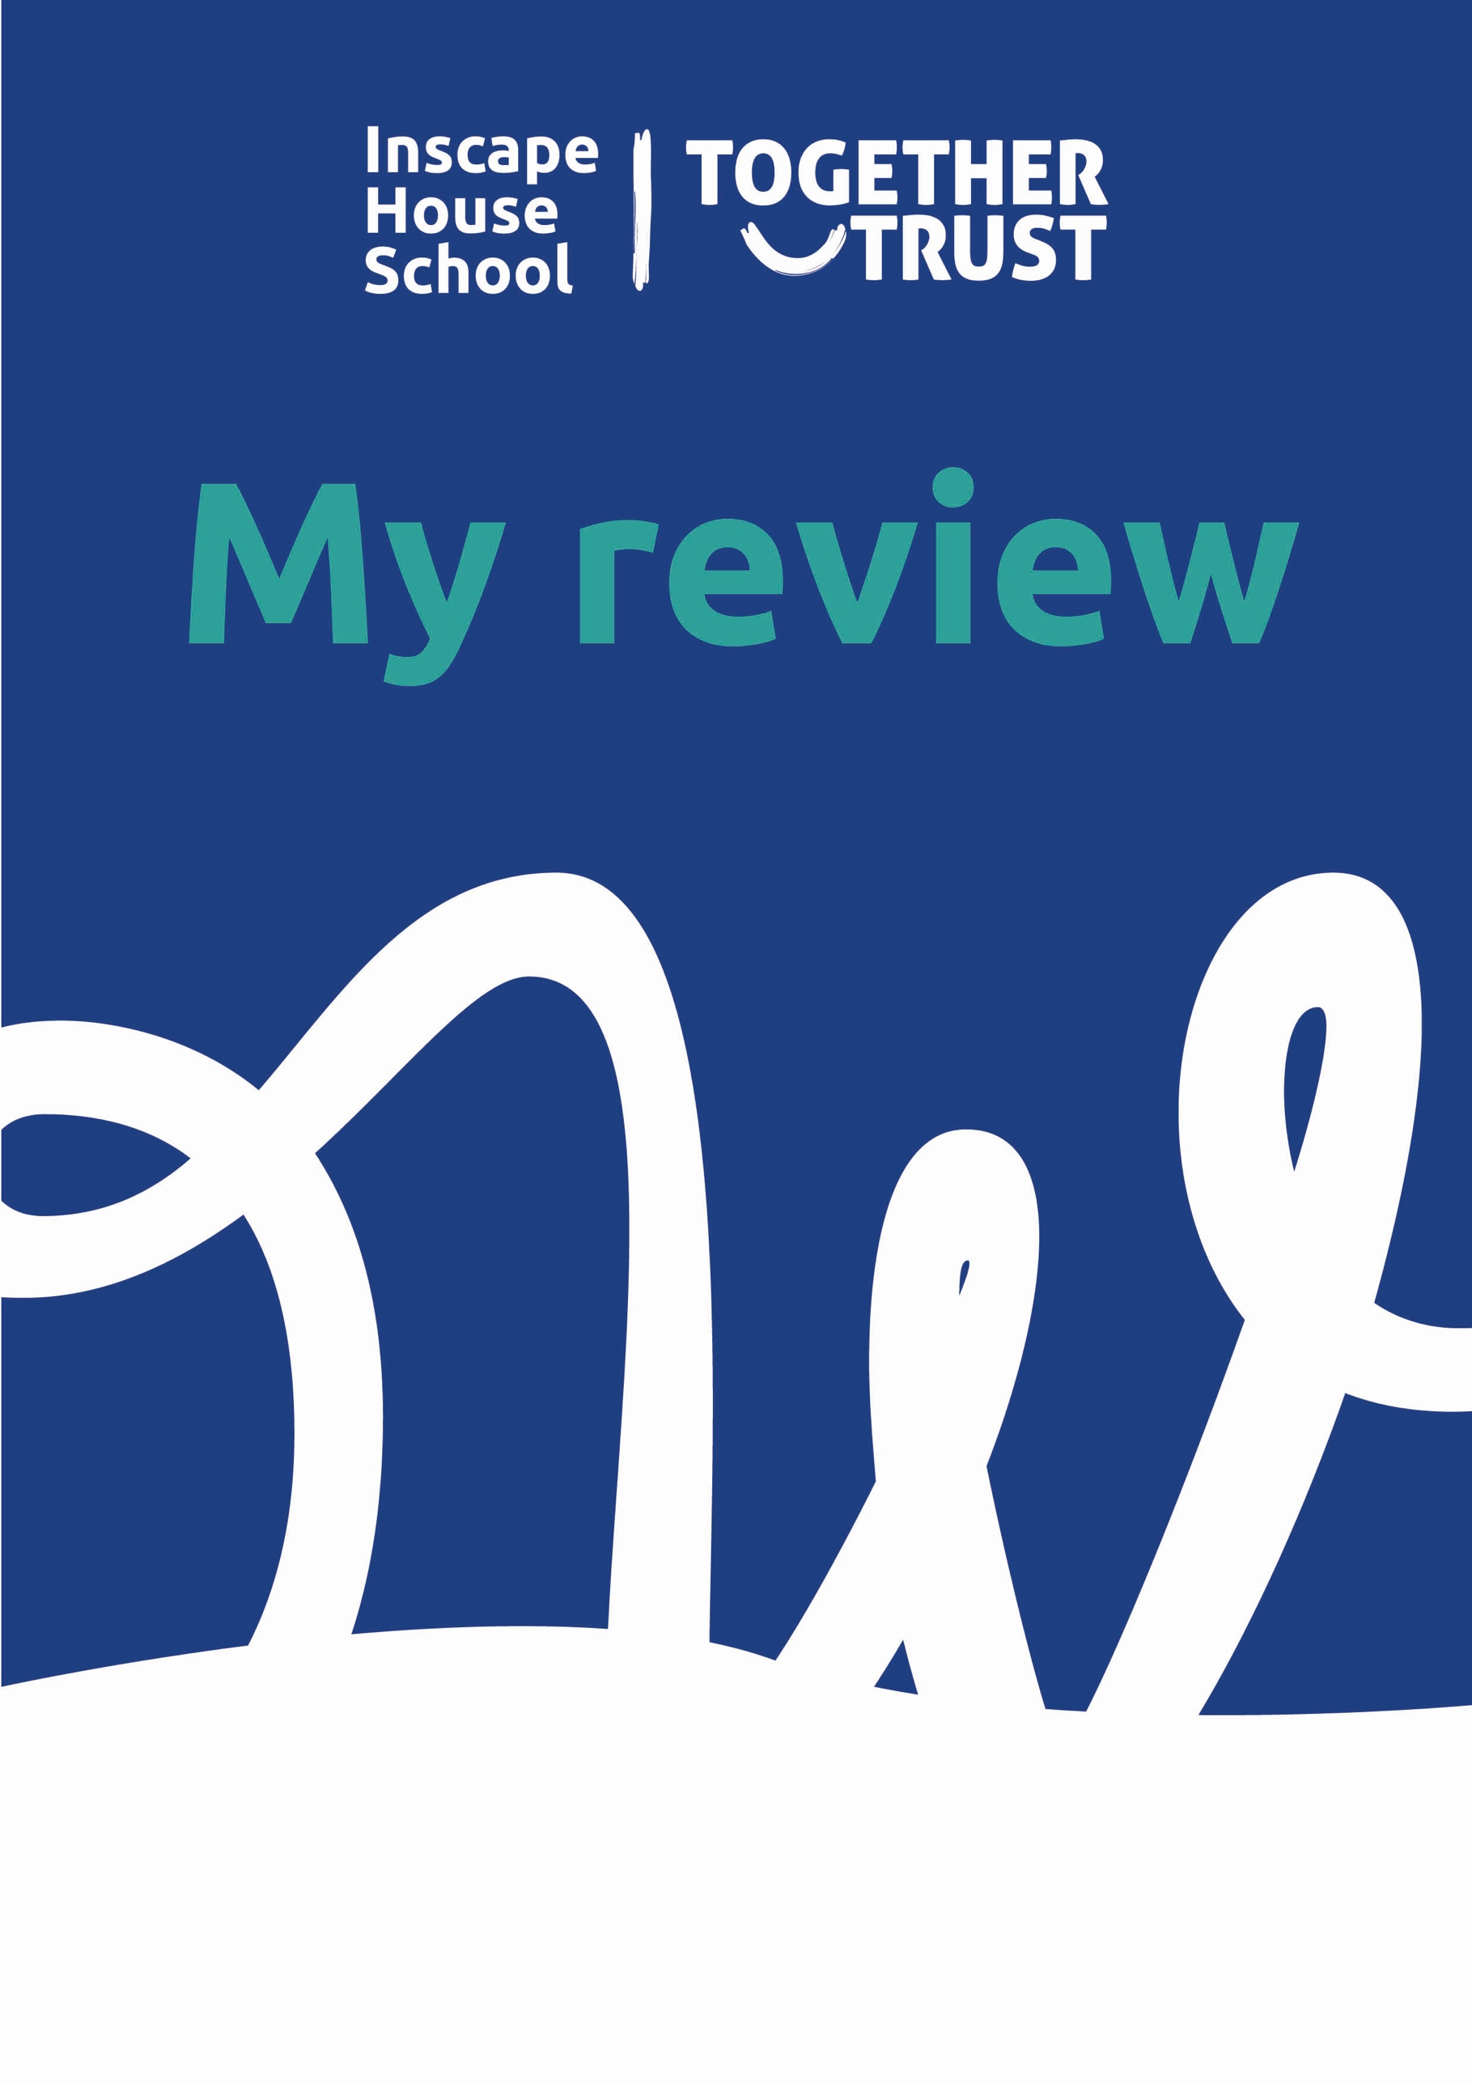
This is a booklet to help you think about your life and plan for your review.
Name:…………………………………………………………

This workbook was completed on:………………………………………………………………….

This workbook was completed by:………………………………………………………………….

You can put information in this booklet in whatever way you want.

You can:

Write
Draw
Stick in photos or pictures

It is up to you. It’s your review!

Just in case you’ve never been to one before have a look through these questions and answers, hopefully they will help you know what’s going to happen. If you have any other questions about your review, you can ask a member of staff and they will try and get the answer for you....

Q: What is an Annual Review?
A: An annual review is a meeting that happens once a year. At the meeting, people talk about what you have been doing at school, the things you have got better at, and what help you might need to do new things or get better at other things.

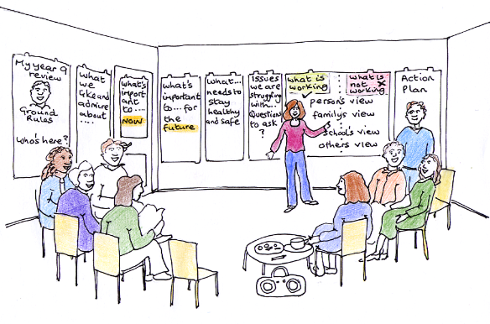

Q. Who is invited to the Annual Review?
A: Your parents or carers are invited to the meeting.
Your teacher is usually invited to the meeting. If you have a speech and language or occupational therapist, they will be invited to the meeting. One of your teachers may lead the meeting or it might be someone from the senior leadership team in Inscape House School. Other people may be invited to the meeting too. You may know some of these people, but you may not have met some of these people before.

You can come to your review if you want to. You can stay for all of the meeting, or just for some of it. If there is someone else you want to be at your meeting, you can ask for them to be invited. Some people who are invited to the meeting may not be able to come. This is OK.

Q. Where will the review be?
A: The review is usually at school. It is usually in the meeting room, but it could be in the family room or in the Cafe you will be told where your review will take place. Reviews are usually online using Teams.

Q. What happens at my review?
A: Everyone invited will sit in the room One person will lead the meeting.
Everyone invited will have access to a computer. You can see everyone on screen. One person will lead the meeting.
There will be large pieces of paper on the walls for people to write on. They all have the same headings as the pages in this booklet.
The person leading the meeting will go through the pages of this booklet. Some comments may have been recorded already.

The meeting will take about an hour and a half. By the end of the meeting, all the people there will have thought of some actions that people can do to help you in your life and your future.

Q. This meeting is all about me. What can I do to be a part of it? How can I let people know what I think?
A: You can be part of the meeting and let people know what you think by:

- Filling in this booklet. (You may want to take copies of the pages from this booklet to stick on the big pieces of paper at the meeting).

- Coming to the meeting and joining in, even just for some of it.

Planning for my review

Q. Who would you like to be at your review?
This might be someone from your family, a friend, or someone who helps you. Write their names here so we can make sure we invite them...

Q. Would you like to come to your review?
You can come to your review. You can stay for all of the review, or just for the first part of it.

Q. What would make you feel comfortable at your review?

Where would you like to sit?
You may want to sit next to a particular person. You may want to sit near the door, or somewhere else in the room.
You will need to sit with someone who is accessing the meeting using a computer. You can choose who that is.

Would you like to bring something with you to your review?
You may want to bring a book, headphones, paper and pens, or something else that you like with you to your review.

What drink or snack would you like at your review?
You can choose to have what you like tea, squash crisps etc.

At the review it is important that there are some rules:
- It is important that people listen to each other
- It is important that people respect what others have to say
- It is important that people maintain confidentiality – this means that they only discuss what has been said at the meeting with the people that need to know.

Can you think of any more rules that you would like to have at your meeting?

Q. What do I like about myself?
Think about all the things that you are good at.
What do you like about yourself?
What is it about you that makes other people like you e.g. your sense of humour, how good you are at art etc.?

Q. What have I achieved this year?
Think about something you might have done that you are really pleased with. Maybe you took an exam and did really well or maybe you walked up Mount Snowdon!

Q. What do I want to achieve next year?
Maybe it’s doing well in GCSEs or maybe it’s making some new friends?

Q. What’s important to me now?
These are the things that really matter to you.
They are often the things that make you happy.
You will probably want these things to stay the same.

Who is important to me now?
Think about the people in your family, your friends, staff at school and other people who may help you and who you like.

Places that I enjoy going to or being at
Maybe the park or McDonalds

Objects and other things which are important to me
Like your iPad or Xbox

Activities and hobbies that are important to me.
Swimming, going out, social media

What’s important to me when you are working with me?
What’s the best way to support me e.g. do I need to go for a walk or listen to my music to help keep me calm? Etc

Q. What is important for my future?
Think about the things you would like to do or have in the future. In the future, some things may change in your life.
Think about the things that you would be happy to happen, and the things that you would NOT like to happen.

Education, employment
Do you want to go to college, be an apprentice, get a job?

Health
Do you have a healthy diet? do you do any exercise? How is your mental health?

Independence
Do you want to live on your own or maybe with others? Can you make yourself a brew, some toast or a roast dinner!

Social and relationships
Would you like to meet new people make new friends?

Q. What is going well?
These are things that are going well for you at the moment.
They are things that you probably would like to stay the same.

What I think

What my family think

What school think

What other people who know me/work with me think

Q. What could be better?
These are things that are NOT going so well at the moment.
They are things that you probably would like to change.

What I think

What my family think

What school think

What other people who know me/work with me think

Q. Questions to ask/issues to resolve
Is there anything else that we haven’t covered in this booklet you want to ask at your review meeting?

